END TO END PRJ- CAR PRICE
Data File Location: C:\Noble\Training\Course Content\Stremlit Deployment and PBI Dashboard
File Name: car_data.csv
Dependent Variable (Y): MSRP

Import the Required Libraries

import pandas as pd
import numpy as np
import seaborn as sns
from matplotlib import pyplot as plt
from sklearn.model_selection import train_test_split
import pickle
import plotly.express as px
import streamlit as st
import os

Update the working directory

os.chdir('C:\\Noble\\Training\\Course Content\\Stremlit Deployment and PBI Dashboard\\')
print (os.getcwd())

Load the dataset

car_data = pd.read_csv("car_data.csv")
display (car_data )

Number of Unique values from each column
If the number of unique values is less than 12, then display the unique values

for column in car_data:
unique_vals = np.unique(car_data[column].fillna('0'))
nr_values = len(unique_vals)
if nr_values <= 12:
print('The number of values for feature {} :{} -- {}'.format(column, nr_values,unique_vals))
else:
print('The number of values for feature {} :{}'.format(column, nr_values))

Display Null values in each column
print (car_data.isnull().sum())

Dropping the columns that have lots of nulls

car_data = car_data.drop(['Invoice Price', 'Cylinders','Highway Fuel Economy'], axis=1)
print (car_data.isnull().sum())

Fill the NULL values in the Horsepower column
Create a new column ‘Horsepower_No’ by getting the first three characters from the column ‘Horsepower’

car_data['Horsepower_No'] = car_data['Horsepower'].str[0:3].astype(float)
display (car_data)

Display the records where 'Horsepower_No' is NULL
There are 5 records where 'Horsepower_No' is null

display (car_data[car_data['Horsepower_No'].isna()])

Display the Average 'Horsepower_No' where car make is “Ford”.
This used to fill the NULL Values in the 'Horsepower_No' cells
All the null values are for the car make, which is Ford

mean_horsepower = car_data['Horsepower_No'][car_data['Make'] == 'Ford'].mean()
print (mean_horsepower )

Fill the NULL 'Horsepower_No' and 'Horsepower' with the Average 'Horsepower_No'

car_data['Horsepower_No'] = car_data['Horsepower_No'].fillna(mean_horsepower)
car_data['Horsepower'] = car_data['Horsepower'].fillna(mean_horsepower)
display (car_data[car_data['Horsepower_No'].isna()])

Fill the NULL values in the Torque column
Create a new column 'Torque_No' by getting the first three characters from the column Torque

car_data['Torque_No'] = car_data['Torque'].str[0:3].astype(float)
print (car_data['Torque_No'])

Display the records where 'Torque_No' is NULL

display (car_data[car_data['Torque_No'].isna()])

Display the Average 'Torque_No'. This used to fill the NULL Values in the Torque cells

mean_torque = car_data['Torque_No'].mean()
print (mean_torque )

Fill the NULL 'Torque_No' and 'Torque' with the Average 'Torque_No'

car_data['Torque_No'] = car_data['Torque_No'].fillna(mean_torque)
car_data['Torque'] = car_data['Torque'].fillna(mean_torque)
print (car_data.isnull().sum())

Display the data types of all columns
print (car_data.dtypes)

Cleaning the column MSRP
Remove the $ symbol and the comma in MSRP

car_data['MSRP'] = car_data['MSRP'].str.replace('$','')
car_data['MSRP'] = car_data['MSRP'].str.replace(',','').astype(float)
display (car_data)

Cleaning the column Used/New Price.
Remove the $ symbol and the comma in Used/New Price.

car_data['Used/New Price'] = car_data['Used/New Price'].str.replace('$','')
car_data['Used/New Price'] = car_data['Used/New Price'].str.replace(',','').astype(float)
display (car_data)

Create the pair plot
sns.pairplot(car_data)
plt.show()

Create the pair plot with a limited number of columns
Hue-'Engine Aspiration'

sns.pairplot(car_data[['MSRP', 'Horsepower_No', 'Torque_No', 'Engine Aspiration']], hue = 'Engine Aspiration', height = 5)
plt.show()

Create the pair plot with a limited number of columns
Hue-'Make'
sns.pairplot(car_data[['MSRP', 'Horsepower_No', 'Torque_No', 'Make']], hue = 'Make', height = 5)
plt.show()

Visualising the categorical values

categories = ['Make','Body Size','Body Style', 'Engine Aspiration', 'Drivetrain','Transmission']

# Increases the size of sns plots
sns.set(rc={'figure.figsize':(14,5)})

for c in categories:
ax = sns.barplot(x=c, y="MSRP", data=car_data, errorbar=('ci', False))
for container in ax.containers:
ax.bar_label(container)
plt.title(c)
plt.show()

Visualising the numerical values with Mean

n_variables = ['MSRP','Used/New Price','Horsepower_No','Torque_No']
# size of sns plots
sns.set(rc={'figure.figsize':(10,5)})

for n in n_variables:
x = car_data[n].values
sns.displot(x, color = 'blue');
# Calculating the mean
mean = car_data[n].mean()

# Plotting the mean- Plot line Y – Axis top to bottom
# plt.axvline() is a Matplotlib function that draws a vertical line on a plot.
# x → the x-position of the vertical line (in your case, the variable mean)
# ymin → bottom of the line (0 = bottom of plot)
# ymax → top of the line (1 = top of plot) , color → line color
plt.axvline(x= mean, ymin = 0,ymax=1, color = 'red')
plt.title(n)
plt.show()

Distribution of Numerical Values
# size of sns plots

sns.set(rc={'figure.figsize':(8,5)})
for c in n_variables:
x = car_data[c].values
ax = sns.boxplot(x, color = '#D1EC46')
print('The meadian of ',c, ': ', car_data[c].median())
plt.title(c)
plt.show()

Distribution of MSRP by categorical variables - by data points
import warnings
warnings.filterwarnings("ignore")

categories = ['Make','Body Size','Body Style', 'Engine Aspiration', 'Drivetrain','Transmission']

# Size of sns plots
sns.set(rc={'figure.figsize':(8,5)})

for c in categories:
ax = sns.boxplot(x=c, y="MSRP", data=car_data, color = '#D1EC46')
ax = sns.swarmplot(x=c, y="MSRP", data=car_data, color="red")
plt.title(c)
plt.show()

Remove the columns which are not required
new_car_data = car_data.drop(['index', 'Model','Year', 'Trim', 'Used/New Price', 'Horsepower', 'Torque'], axis=1)
display (new_car_data )

One-hot encoding on the selected columns
new_car_data = pd.get_dummies(new_car_data, columns = ['Make','Body Size','Body Style', 'Engine Aspiration', 'Drivetrain','Transmission'], dtype='int')

display (new_car_data.head())
Display the correlation matrix

n_variables = ['MSRP','Horsepower_No','Torque_No']
pc = new_car_data[n_variables].corr(method ='pearson')
print (pc)

Display the heatmap

sns.set(rc={'figure.figsize':(12,4)})
cols = n_variables
ax = sns.heatmap(pc, annot=True,
yticklabels=cols,
xticklabels=cols,
annot_kws={'size':10},
cmap="Blues")

Create Independent Variable – X
X = new_car_data.drop(['MSRP'], axis = 1).values
print(X.shape)

Create Dependent Variable – Y

y = new_car_data['MSRP'].astype(int)
print(y.shape)

Train Test Split
X_train, X_test, y_train, y_test = train_test_split(X, y, train_size=0.80, test_size = 0.2, random_state=15)
print(X_train.shape)
print(X_test.shape)
print(y_train.shape)
print(y_test.shape)

Create Linear Regression

from sklearn.linear_model import LinearRegression
from sklearn.metrics import r2_score, explained_variance_score, mean_absolute_error, mean_squared_error
from math import sqrt

# Training the Regression
lm = LinearRegression()
lm.fit(X_train, y_train)

Prediction with Training Data
ytrain_pred = lm.predict(X_train)
print (ytrain_pred )

Prediction with Test Data
ytest_pred = lm.predict(X_test)
print (ytest_pred )

Prediction with Complete Data
all_df_predict = lm.predict(X)
print (all_df_predict)

Display accuracy and Error for Training, Test and Complete Data

print('The Accuracy on the training dataset is: ', lm.score(X_train, y_train) )
print('The Accuracy r2 on the training dataset prediction is: ',r2_score(y_train,ytrain_pred) )
print("")

# Model Accuracy on testing dataset

print('The Accuracy on the testing dataset is: ', lm.score(X_test, y_test) )
print('The Accuracy r2 on the testing dataset prediction is: ',r2_score(y_test,ytest_pred) )
print("")

# Model Accuracy on Complete Data Set
print('The Accuracy on the Complete dataset is: ', lm.score(X, y) )
print('The Accuracy r2 on the Complete dataset prediction is: ',r2_score(y,all_df_predict) )
print("")

# The Root Mean Squared Error (RMSE)
print('The RMSE on the training dataset is: ',sqrt(mean_squared_error(y_train,ytrain_pred)))
print('The RMSE on the testing dataset is: ',sqrt(mean_squared_error(y_test,ytest_pred)))
print('The RMSE on the Complete dataset is: ',sqrt(mean_squared_error(y,all_df_predict)))

print("")
# The Mean Absolute Error (MAE)
print('The MAE on the training dataset is: ',mean_absolute_error(y_train,ytrain_pred))
print('The MAE on the testing dataset is: ',mean_absolute_error(y_test,ytest_pred))
print('The MAE on the Complete dataset is: ',mean_absolute_error(y,all_df_predict))

print("")
# Coefficients
print('Coefficients: ', lm.coef_ )

print("")
# The Intercept
print('Intercept: ', lm.intercept_)

Export all the data with predictions

car_data['MSRP Predictions'] = all_df_predict
car_data.to_excel("data_with_pred.xlsx")
display (car_data)

Create Pickle, Deployment File
pickle.dump(lm, open('linear_model.pkl','wb'))

Prediction with Pickle File
model=pickle.load(open('linear_model.pkl','rb'))
# Prediction
print (model.predict (X_test))

Streamlit Code
PY file Name: Car_Price.py
File Location: C:\Noble\Training\Course Content\Stremlit Deployment and PBI Dashboard

VS Code Page Screenshot

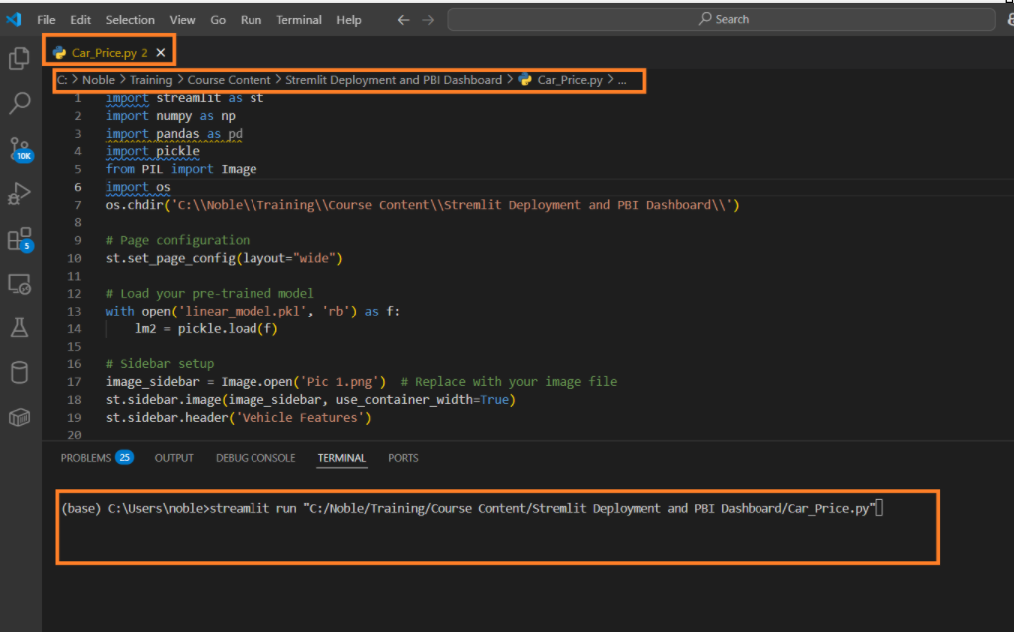

Command to run streamlit file

streamlit run "C:/Noble/Training/Course Content/Stremlit Deployment and PBI Dashboard/Car_Price.py"

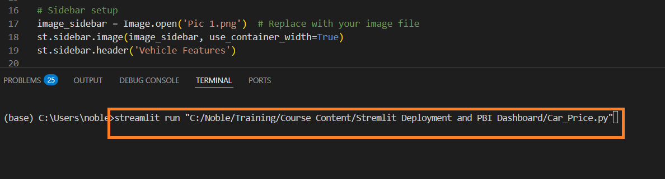

Open streamlit Web page
After executing the run streamlit command, the Streamlit web page opens in the default browser
Or use the URL to open Streamlit

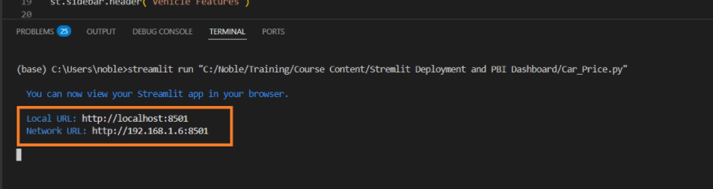

Shot cut to come out from Streamlit App
CTRL+C

Py File Content

import streamlit as st
import numpy as np
import pandas as pd
import pickle
from PIL import Image
import os
os.chdir('C:\\Noble\\Training\\Course Content\\Stremlit Deployment and PBI Dashboard\\')

# Page configuration
st.set_page_config(layout="wide")

# Load your pre-trained model
with open('linear_model.pkl', 'rb') as f:
lm2 = pickle.load(f)

# Sidebar setup
image_sidebar = Image.open('Pic 1.png') # Replace with your image file
st.sidebar.image(image_sidebar, use_container_width=True)
st.sidebar.header('Vehicle Features')

# Feature selection on sidebar. This function is used to enter input data
def get_user_input():
horsepower = st.sidebar.number_input('Horsepower (No)', min_value=0, max_value=1000, step=1, value=300)
torque = st.sidebar.number_input('Torque (No)', min_value=0, max_value=1500, step=1, value=400)

make = st.sidebar.selectbox('Make', ['Aston Martin', 'Audi', 'BMW', 'Bentley', 'Ford', 'Mercedes-Benz', 'Nissan'])
body_size = st.sidebar.selectbox('Body Size', ['Compact', 'Large', 'Midsize'])
body_style = st.sidebar.selectbox('Body Style', [
'Cargo Minivan', 'Cargo Van', 'Convertible', 'Convertible SUV', 'Coupe', 'Hatchback',
'Passenger Minivan', 'Passenger Van', 'Pickup Truck', 'SUV', 'Sedan', 'Wagon'
])
engine_aspiration = st.sidebar.selectbox('Engine Aspiration', [
'Electric Motor', 'Naturally Aspirated', 'Supercharged', 'Turbocharged', 'Twin-Turbo', 'Twincharged'
])
drivetrain = st.sidebar.selectbox('Drivetrain', ['4WD', 'AWD', 'FWD', 'RWD'])
transmission = st.sidebar.selectbox('Transmission', ['automatic', 'manual'])

# Explanation for f'Body Size_{body_size}'
# The value assigned to variable body_size conctinated with Body Size_
# f is for formatted output string

# Example
# body_size='Compact'
# x= f'Body Size_{body_size}'
# print (x)

# Output : Body Size_Compact

user_data = {
'Horsepower_No': horsepower,
'Torque_No': torque,
f'Make_{make}': 1,
f'Body Size_{body_size}': 1, #When ever you select a value related category assigned to 1, Default all categories 0
f'Body Style_{body_style}': 1,
f'Engine Aspiration_{engine_aspiration}': 1,
f'Drivetrain_{drivetrain}': 1,
f'Transmission_{transmission}': 1,
}
return user_data

# Top banner
image_banner = Image.open('Pic 2.png') # Replace with your image file
st.image(image_banner, use_container_width=True)

# Centred title
st.markdown("<h1 style='text-align: center;'>Vehicle Price Prediction App</h1>", unsafe_allow_html=True)

# Split layout into two columns
left_col, right_col = st.columns(2)

with left_col:
st.header("Feature Details")

# User inputs from sidebar
user_data = get_user_input()
st.write (user_data)
# Right column: Prediction Interface
with right_col:
st.header("Predict Vehicle Price")

# Transform the input into the required format
def prepare_input(data, feature_list):
input_data = {feature: data.get(feature, 0) for feature in feature_list}
return np.array([list(input_data.values())])

# Feature list (same order as used during model training)
features = [
'Horsepower_No', 'Torque_No', 'Make_Aston Martin', 'Make_Audi', 'Make_BMW', 'Make_Bentley',
'Make_Ford', 'Make_Mercedes-Benz', 'Make_Nissan', 'Body Size_Compact', 'Body Size_Large',
'Body Size_Midsize', 'Body Style_Cargo Minivan', 'Body Style_Cargo Van',
'Body Style_Convertible', 'Body Style_Convertible SUV', 'Body Style_Coupe',
'Body Style_Hatchback', 'Body Style_Passenger Minivan', 'Body Style_Passenger Van',
'Body Style_Pickup Truck', 'Body Style_SUV', 'Body Style_Sedan', 'Body Style_Wagon',
'Engine Aspiration_Electric Motor', 'Engine Aspiration_Naturally Aspirated',
'Engine Aspiration_Supercharged', 'Engine Aspiration_Turbocharged',
'Engine Aspiration_Twin-Turbo', 'Engine Aspiration_Twincharged',
'Drivetrain_4WD', 'Drivetrain_AWD', 'Drivetrain_FWD', 'Drivetrain_RWD',
'Transmission_automatic', 'Transmission_manual'
]

# Predict button
if st.button("Predict"):
input_array = prepare_input(user_data, features)
prediction = lm2.predict(input_array)
st.subheader("Predicted Price")
st.write(f"${prediction[0]:,.2f}")

# streamlit run "C:/Noble/Training/Course Content/Stremlit Deployment and PBI Dashboard/Car_Price.py"
# Press CTRL +C to exist stremlit

